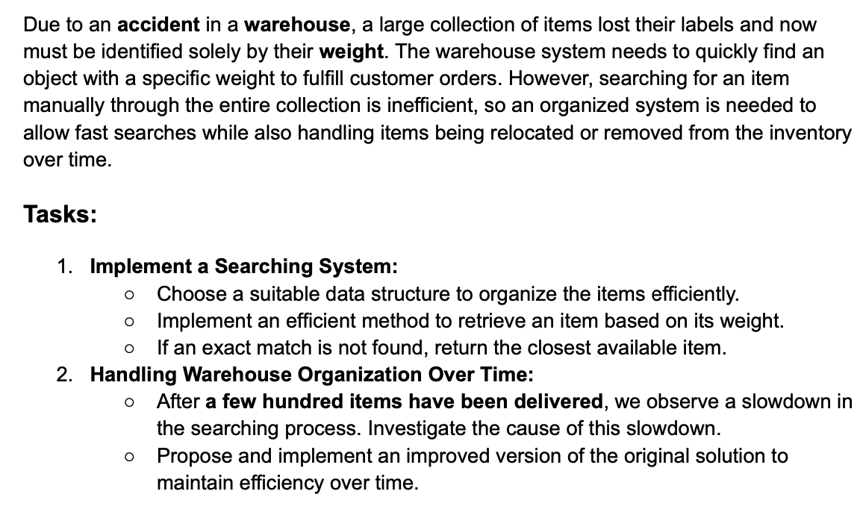
Task 1:
The data structure I implemented for the warehouse is a sorted array. I implemented this by actively inserting each new element into a sorted position in the array.
An efficient method to retrieve an item based off its weight was done using binary search.
If the exact element was not found, it would return the closest available item. This was done by comparing the value before and after where this item would be.
The implementation can be seen here:
Insert python code.
Task 2:
A slowdown was noticed when a large number of items were added. Especially in the removing items and adding items process.
This could be because a linear search is done to find the item that is needed to be removed, or the position where the new element is to be added. This can be improved by implementing a binary search algorithm to find the item to be removed, or the position the new element is to be added. This is currently only being implemented in the find_item function. The improvement can be seen below, where binary insertion and removal has been added.
Insert Python code

